021 TypeScript - callbacks

TypeScript Kata List – Blog Page

[TypeScript Kata List on GitHub](https://github.com/robertdunaway/katas-typescript)

# Duration

10 minutes

# Brief

Functions can be passed into other functions and returned from functions. Passing functions into another function is a call back.

### For More Information

BING/GOOGLE: “TypeScript callbacks”

# Instructions

Get tutorial folder or the entire katas-typescript repo.

Open the [before/*.sln] file and execute the kata.

Feel free to execute this kata multiple times because repetition creates motor memory.

# Github

* Before (start kata with this)
  + https://github.com/robertdunaway/katas-typescript/tree/master/021%20TypeScript%20-%20callbacks/before
* After
  + https://github.com/robertdunaway/katas-typescript/tree/master/021%20TypeScript%20-%20callbacks/after

# Kata

Create a simple function that you can use as a callback function that only outputs some short text message to the console.

Create a function that accepts a function as a callback and then calls the callback function.

Now call your new function and pass in your simple output function.

// create a function to be used as a callback. This is our callback function.

var myCB = function () {

console.log('The callback just ran...');

};

// create a function and pass in the callback method.

function myFunction(cb: () => void) {

cb();

}

myFunction(myCB); // calling the new function and pass in the callback.

Now create a new function, used as a callback, that accepts a value that will be outputted to the console log.

Create a function that receives the callback as a parameter and calls the callback. This function should accept a callback function and two numbers that will be added together and sent to the callback.

// create another callback function whose job is to output whatever it's

// passed back to display. If nothing is passed back then output a default value.

var myConsoleLog = function (output: string = 'Nothing was passed back to output') {

console.log(output);

}

// create a function and pass in the callback method.

function add(cb: (string) => void, a: number, b: number) {

var c = a + b;

cb('a + b = ' + c);

}

// call the new add function and pass in the callback function and two numbers.

add(myConsoleLog, 2, 3);

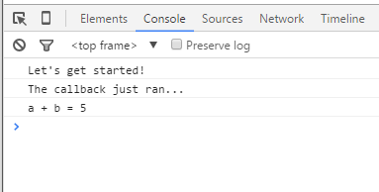

# Next

Take a few minutes and imagine more examples.